**CAVITY LTD. MOBILE PHONE PRICE PREDICTION AND PERFORMANCE ANALYSIS**

**Analysis Insight**

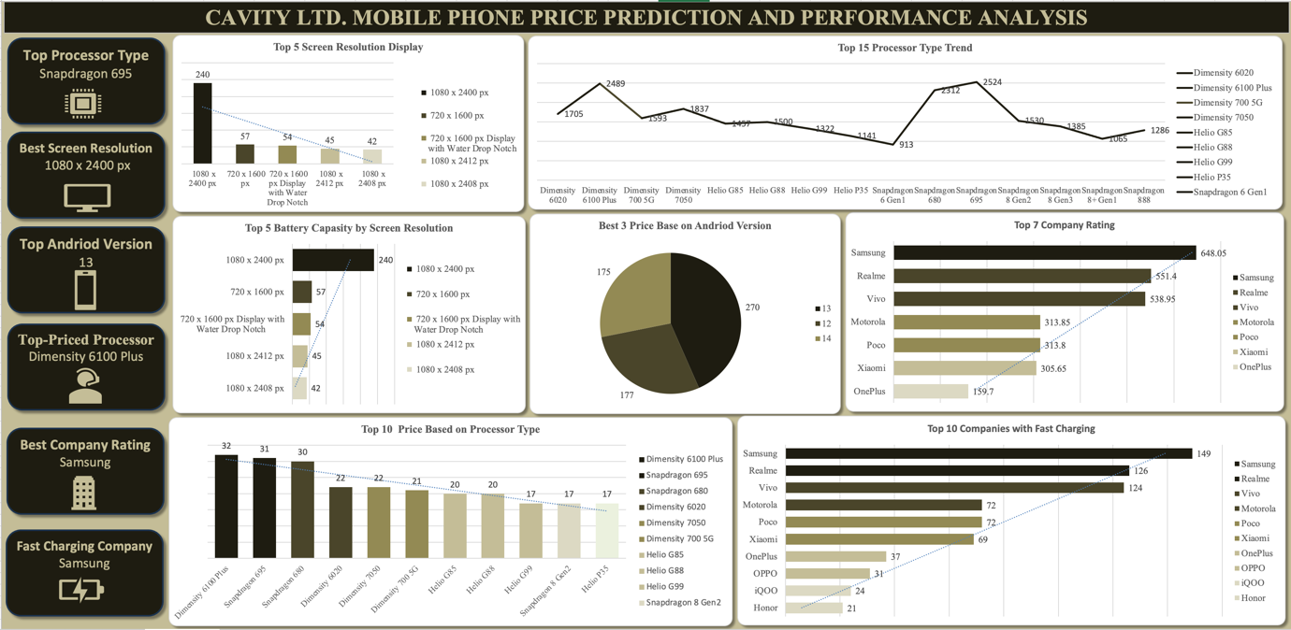

**Observations:**

1. **Top 5 Screen Resolutions by Display Popularity:**

The **1080 x 2400px** resolution leads with a total of 240 instances, indicating that this resolution is currently the most preferred among users, likely due to its balance of clarity and screen size for mid-to-high range devices.

The **720 x 1600px** resolution comes second with 57 occurrences, suggesting it's popular in budget to mid-range phones, offering decent display quality.

**720 x 1600px with a Water Drop Notch** is in third place with 54 devices featuring this display style, showing a preference for this aesthetic design in more affordable phone segments.

The **1080 x 2412px** resolution ranks fourth with 45 instances, suggesting it's a choice for slightly higher-end devices within the mid-range category.

The **1080 x 2408px** resolution is fifth, appearing 42 times, indicating it's another variant favored for mid-range devices, offering similar performance to the top choice.

1. **Top 5 Battery Capacities by Screen Resolution:**

The **1080 x 2400px** screen resolution again leads in battery capacity, with 240 entries, showing that phones with this resolution often come equipped with larger batteries to support high-resolution displays.

**720 x 1600px** is second with 57 cases, indicating it also commonly features solid battery performance, likely appealing to budget-conscious users who need good battery life.

**720 x 1600px with a Water Drop Notch** ranks third with 54 occurrences, again highlighting a preference for combining affordable design with decent battery capacity.

The **1080 x 2412px** resolution is fourth, appearing in 45 cases, reflecting that these screens are usually paired with batteries that can support their resolution needs.

**1080 x 2408px** rounds out the top five with 42 devices, indicating manufacturers balance this resolution with battery efficiency.

1. **Spec Score by Processor:**

**Snapdragon 695** has the highest performance score at 2524, demonstrating it is a popular choice for mid-range devices that need solid processing power.

**Dimensity 6100 Plus** closely follows with a score of 2489, indicating it is a strong competitor in the mid-range market with balanced efficiency and performance.

**Snapdragon 680** ranks third with a score of 2312, highlighting its reliability in budget-friendly phones that still require reasonable processing capability.

**Dimensity 7050** comes in fourth with a score of 1837, indicating it is a decent performer, often chosen for devices in the affordable-to-mid-range category.

**Dimensity 6020** is fifth with a score of 1705, showing it is used in entry-level to mid-range phones where efficiency is prioritized over high-end performance.

Lower down, **Snapdragon 8+ Gen1** (1065) and **Snapdragon 6 Gen1** (913) are found in the fourteenth and fifteenth positions, indicating that these processors are likely reserved for more specialized or budget devices with niche use cases.

1. **Top 3 Prices by Android Version:**

Android **13** is the most associated with higher-priced devices, leading with 270 instances, suggesting it is the choice for recent and flagship models.

Android **12** follows with 177 instances, indicating it is still widely used in many mid-to-upper-range devices as an earlier version of the OS.

Android **14** has 175 instances, reflecting its adoption in newer high-end devices that are pushing the boundaries with the latest software features.

1. **Top 7 Most Rated Companies by User Feedback:**

**Samsung** leads with a rating score of 648.05, showing it is the most highly rated and perhaps trusted brand among users, known for its diverse range of devices across various price points.

**Realme** is second with 551.4, indicating its strong market presence, especially in the budget and mid-range segments where it delivers competitive features.

**Vivo** holds third place with 538.95, highlighting its popularity, especially in regions that value camera quality and stylish design.

**Motorola** ranks fourth at 313.85, showing steady popularity, likely due to its focus on durable, budget-friendly phones with clean software experiences.

**Poco** follows closely at 313.8, reflecting its appeal in the budget sector, where it provides value for money with solid specs.

**Xiaomi** is next with a rating of 305.65, known for affordability and a wide range of device choices, particularly in the mid-range.

**OnePlus** is seventh at 159.7, indicating it maintains a niche following, especially among users who appreciate a premium feel at a competitive price.

1. **Top 10 Prices Based on Processor Type:**

**Dimensity 6100 Plus** leads with 32 instances, indicating it is associated with higher prices, likely due to its recent introduction and balanced performance.

**Snapdragon 695** follows with 31 instances, another indication of its mid-range popularity.

**Snapdragon 680** has 30 cases, showing it's commonly used in slightly lower-cost devices that still offer good performance.

**Dimensity 6020** and **Dimensity 7050** each appear twice, suggesting they are used in a limited number of higher-priced models or specialized devices.

**Dimensity 700 5G** has 21 entries, showing it is a common choice in budget 5G phones.

**Helio G85** and **Helio G88** each have 20 instances, reflecting their use in budget and mid-range phones focused on affordability.

**Helio G99**, **Snapdragon 8 Gen2**, and **Helio P35** each appear 17 times, highlighting a mix of entry-level to mid-range devices using these processors.

1. **Top 10 Companies with Fast Charging Capabilities:**

**Samsung** tops the list with 149 models featuring fast charging, indicating its commitment to delivering reliable and quick-charging solutions across various price points.

**Realme** is second with 126 fast-charging models, emphasizing its focus on convenience and cutting-edge technology in budget and mid-range categories.

**Vivo** follows closely with 124, showcasing its dedication to modern conveniences, particularly in mid-range to upper-tier devices.

**Motorola** and **Poco** are tied with 72 models each, indicating their emphasis on fast charging as a key feature in the mid-range market.

**Xiaomi** offers 69 models with fast charging, reinforcing its reputation for budget-friendly devices with competitive features.

**OnePlus** is next with 37 models, reflecting its focus on premium devices with robust fast-charging technology.

Other brands like **OPPO**, **iQOO**, and **Honor** feature 31, 24, and 21 models, respectively, indicating their targeted approach to include fast charging in selected segments for user convenience.

This detailed analysis reveals key patterns in display preferences, battery capacities, processing power, Android versions, brand ratings, pricing based on processors, and fast charging capabilities. Each insight helps inform strategic product development, marketing efforts, and consumer guidance for making informed purchasing decisions in the mobile phone market.

**Recommendation:**

1. **Enhance Mid-Range Offerings with Popular Screen Resolutions:**

With the **1080 x 2400px** resolution leading in popularity, focus on incorporating this resolution in mid-range devices. This resolution strikes a balance between performance and visual quality, making it a desirable choice for a wide audience.

Consider launching budget-friendly devices featuring **720 x 1600px** and **720 x 1600px with Water Drop Notch**, as these resolutions show strong popularity among users seeking affordability without sacrificing display quality.

Explore offering **1080 x 2412px** and **1080 x 2408px** resolutions in mid-range models to cater to users who appreciate slightly more advanced displays but are budget-conscious. Highlight the clarity and experience benefits in marketing these resolutions.

1. **Optimize Battery Life in Key Display Segments:**

Since devices with **1080 x 2400px** resolution also lead in battery capacity, ensure that future phones in this segment are equipped with high-capacity batteries to support longer screen time and intensive usage.

Focus on balancing battery efficiency for phones featuring **720 x 1600px** resolution, a popular choice for budget models, by including efficient power management features or optimized hardware configurations.

Consider using battery performance as a marketing differentiator, especially for **1080 x 2412px** and **1080 x 2408px** displays, which are used in mid-range devices. Emphasize battery efficiency to appeal to heavy users who value longer battery life.

1. **Target Processor Choices to Specific Market Segments:**

Emphasize mid-range and affordable models featuring **Snapdragon 695**, **Dimensity 6100 Plus**, and **Snapdragon 680**, as these processors rank highly in performance scores. They are well-suited for users who seek reliable performance without premium prices.

Explore offering **Dimensity 7050** and **Dimensity 6020** in devices targeting budget-conscious users who still need decent processing power. Use these processors in budget-friendly models with appealing features.

Clearly segment the market by associating flagship models with advanced processors like **Snapdragon 8+ Gen1**. Position these models to appeal to tech enthusiasts who prioritize high-end performance and are willing to invest in premium devices.

1. **Promote the Latest Android Versions for Enhanced User Experience:**

Prioritize updating and releasing devices with Android **13** and **14**, as these versions are associated with higher-priced devices, suggesting that consumers perceive them as offering better features and a more up-to-date experience.

Consider gradually phasing out older Android versions in mid-range and high-end devices while maintaining Android **12** for budget-friendly phones to cater to markets that are sensitive to price yet desire familiar functionality.

1. **Brand Positioning and Marketing Based on User Ratings:**

Leverage **Samsung’s** strong reputation and top rating to solidify its brand image as a leader in reliability and feature-rich devices. Use user testimonials and brand loyalty in advertising campaigns.

For **Realme** and **Vivo**, emphasize affordability, modern design, and camera capabilities, which are likely the key reasons behind their high ratings. Focus on mid-range devices with value-added features like fast charging and premium design.

For brands like **Motorola** and **Poco**, highlight durability, clean software experiences, and cost-effectiveness in promotions to attract budget-conscious buyers who want dependable performance.

Use **Xiaomi’s** competitive pricing and feature diversity to target consumers seeking a balance between performance and affordability. Highlight frequent updates and feature-rich software in marketing.

Emphasize **OnePlus** as a brand that offers a premium experience at competitive prices, focusing on performance, fast charging, and sleek design in flagship devices.

1. **Strategic Use of Processors to Maximize Price Segmentation:**

Continue using **Dimensity 6100 Plus** and **Snapdragon 695** for mid-range models, as they dominate the top price categories. Emphasize their performance in multitasking, gaming, and camera capabilities to attract tech-savvy consumers.

Utilize **Snapdragon 680** for slightly lower-priced models to appeal to a broader audience who value solid performance without the premium tag.

Limit the use of niche or lower-scoring processors like **Snapdragon 8 Gen2** to specific flagship models where premium pricing is justifiable. Differentiate these devices by focusing on high-end specs and luxury features.

1. **Highlight Fast Charging Capabilities as a Key Selling Point:**

Given **Samsung’s** leadership in fast-charging devices, continue to innovate and market this feature heavily across all price ranges, focusing on safety, efficiency, and quick power-up times.

For **Realme**, **Vivo**, and **Xiaomi**, continue developing fast-charging technology for mid-range and budget devices, using it as a unique selling proposition to differentiate from competitors. Highlight the convenience and quick turnaround time for daily use.

Promote fast-charging features in marketing campaigns, particularly in regions where power outages are common or consumers highly value efficiency.

Collaborate with retailers and network providers to demonstrate fast-charging capabilities through in-store demos and promotions, especially for **OnePlus**, **Motorola**, and **Poco** devices, which also rank high in this category.

1. **Increase Emphasis on Display, Battery, and Processing Power in Product Advertising:**

Focus advertising on the top-performing specifications, particularly screen resolution and battery capacity, as they significantly influence purchase decisions.

Highlight the advantages of the **1080 x 2400px** resolution in providing high-quality visual experiences without excessive strain on battery life.

Tailor marketing messages to specific audience needs: gamers (processing power), professionals (battery and multitasking efficiency), and general consumers (balance of performance and price).

By following these recommendations, Cavity Ltd. can effectively optimize its mobile phone offerings, target key market segments, and enhance brand loyalty by meeting diverse consumer expectations in the rapidly evolving mobile market.

**Key Takeaways**

**Resolution and Battery Capacity:** High-resolution screens are a priority for mid-range consumers who also value longer battery life.

**Processor Influence:** Processor choice significantly affects both device performance and price, with distinct market segments gravitating toward specific processors.

**Android Version Trends:** Keeping devices updated with the latest Android versions can justify higher prices and attract tech-savvy consumers.

**Brand Trust and Market Positioning:** Major brands like Samsung maintain their leadership by balancing innovation with reliability, while emerging brands gain traction through competitive pricing and features.

**Importance of Fast Charging:** Quick charging capabilities have become a crucial feature, influencing consumer preferences, particularly in the mid-range and upper segments.

These insights suggest that Cavity Ltd. should tailor its strategy to emphasize high-demand features like display quality, battery life, fast charging, and up-to-date software to align with consumer expectations in the competitive mobile phone market.